Congratulations!
Congratulations on purchasing a Maus-Tec® Electronics Edge-o-Matic® 3000, an automated orgasm denial and edging device, with network connectivity and advanced features!
This user manual should help you better understand the use, care, and safety considerations of your new Edge-o-Matic 3000. Please read this manual carefully, paying special attention to any warnings and highlighted information.


DO NOT OVER INFLATE YOUR BUTT PLUG. As with any insertable sex toy, please use caution and operate responsibly. If you experience pain or discomfort during use, immediately stop before you hurt yourself.

Be sure to clean the insertable components and sex toys after use, follow proper hygiene with your toys, and never store them wet. That is how you get mold. You can wipe the electronics down with a damp isopropyl alcohol wipe.

The RJ45 expansion port on the right is NOT AN ETHERNET JACK. This expansion port is for use with only approved Maus-Tec accessories. If you hook this up to your LAN you can seriously damage your device. Don’t do it.
Only use approved attachments and accessories with the Edge-o-Matic 3000. This includes different power adaptors. If you are not certain your device is compatible with the base unit, you can contact Maus-Tec for support.
Do not submerge the Edge-o-Matic in water, drop it, or otherwise abuse the device. If you spill fluids on the device, you can clean it with a damp isopropyl alcohol wipe. Allow the unit to completely dry before use.
This device’s firmware and control protocol are open source, and you are free to upload your own software, however, Maus-Tec does not support 3rd party firmware or accessories. If you upload custom firmware, you are doing so at your own risk.

Use lube, take it slow and easy, and do not hurt yourself. With great butt plug comes great responsibility. Maus-Tec is not responsible for you slipping on your own lube spillage or bodily fluids, though if used correctly, the latter may not ever expel.
When using the vibrator, check the temperature every so often. Take special care to be sure it does not overheat.

The Edge-o-Matic 3000 continues to receive new firmware updates with feature upgrades and improvements, and so the contents of this manual may not reflect the current state of your device. For the most up-to-date information, please refer to the Maus-Tec Electronics website!

Table of Contents
Congratulations! 1
Table of Contents 3
Box Contents 4
Initial Setup 5
First Session Setup 6
Configuring Wireless 8
Hardware Features 9
Main Screen 10
Chart View 12
Manual Operation 12
Automatic Edging Mode 13
Main Menu 14
Edging Settings 15
Orgasm Settings 17
UI Settings 19
Network Settings 19
Using the SD Card 20
SD Card Continued 24
Data Recording 25
Installing Firmware Updates 26
Conclusion 27

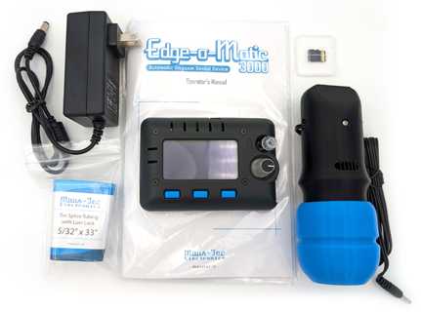
Box Contents
5
4
3
2
1

Figure 1 - Box Contents
- AC Power Supply (style varies depending on region)
- Vibrator Wand
- Edge-o-Matic 3000
- Micro SD card w/ Configuration (installed in unit)
- Air line for butt plug connection

Initial Setup
Before setting up your device, double check the Box Contents and make sure you have the Air Line Assembly ready. You will also need a pair of scissors or sharp knife to splice your butt plug’s airline. Please see the provided insert graphic for additional help.
- Cut your butt plug’s airline about 1.5 – 3 inches below the inflation bulb (hand pump). Attach the two ends to the plastic “tee” connector at the end of the Air Line Assembly.
- Connect the luer lock end of the Air Line to the luer lock end Air Inlet Port on the Edge-o-Matic 3000. Also connect the vibrator or any accessory you are using.
- Ensure the SD card is inserted in the unit. You could also check out the default config files and set up your Wi-Fi information (described in the next section) before putting it in. Be careful to align it correctly!
- Connect the supplied power supply to the unit and plug it into the wall. At this point, the device should boot up.
Do not insert or remove the SD card while the device is powered on. This will not necessarily harm the device, but will result in data loss, especially if using the session recorder. Furthermore, the settings on the SD card are only read when the device first boots.
At this point the device should be on the home screen. When you are ready for your session, you can continue to the next setup section.

First Session Setup
Some calibration may be required for your first session. When you are ready to go, fetch your device, vibrator, butt plug, lube and any other accessories. Now is a great time to go re-read the safety precautions on the first page just in case you might have skimmed past those.
- Prior to inserting the plug, open the valve on the plug without squeezing it to equalize pressure. Close the valve.
- Lube up and carefully insert the plug. Follow all other relevant safety precautions. If pain or discomfort occurs, stop what you're doing and consult a guide on proper insertion. Nothing should be painful.
- Once inserted and seated properly, you shouldn’t have to add additional air. However, a small pump could help under some circumstances, experimentation is necessary. If you over-inflate the anal plug it will compress your butt muscles and prevent them from contracting, which defeats the function of the device. In many cases, no pumps added to the plug works best.
- Enter the Edging Settings menu and adjust the Sensor Sensitivity until the bar graph display is just higher than half way full, while your backside is relaxed.
- Save and exit the menu, return to the home screen, and give your butt a squeeze. You should see pressure readings fluctuate. This works for most people, however per step 3, experimentation with different pressures may be required.
- It is recommended that you change to Depletion Mode to help with calibration. This setting can be found in Edging Settings menu, under Vibration Mode. This will slow vibration gradually as you approach the Arousal Threshold.
- Once calibrated, begin Automatic Edging. During the edging process, attempt to keep your butt relaxed and try not to think about the plug, it's just collecting data.
- When you feel yourself approaching orgasm, turn the Arousal Threshold down* until the shaded area of the Arousal Meter gets close to the solid meter reading (on the Stats page). Adjust as needed during your session.**
* The value selected may seem low, but this is actually an arbitrary value and it starts off very high. Pressure fluctuations and arousal counts are an extremely small number as this is reading quite small muscle contractions.
** Over the course of edging, your body signals may change. It is not uncommon for the peaks to become less intense as time goes on.
You may have to repeat this calibration procedure with different values until you find a combination of Sensor Sensitivity, Arousal Threshold and anal plug pressure that works for you.
Read on for more advanced configuration options, including setting automatic ramp-up time, motor max speed, and various detection settings for tuning pressure change detection.

Configuring Wireless
Wireless network configuration must be done by setting your Wi-Fi credentials in the config.json file. This file is located on the SD card and can be edited in any text editor. See “Using the SD Card” for more information on editing config.json.
Your Wi-Fi SSID (network name) and encryption key (password) should be set in the following fields between normal double quotes. Leave the rest of the formatting of this file alone:
{
...
"wifi_ssid": "Network Name",
"wifi_key": "Network Password",
...
}
Once Wireless is configured, you can view network status and enable/disable Wi-Fi from the “WiFi Settings” menu. To view your device’s IP address, select “WiFi Settings > Connection Status”
The Edge-o-Matic 3000 only supports a 2.4GHz network connection, it will not connect to a 5GHz network.

Hardware Features
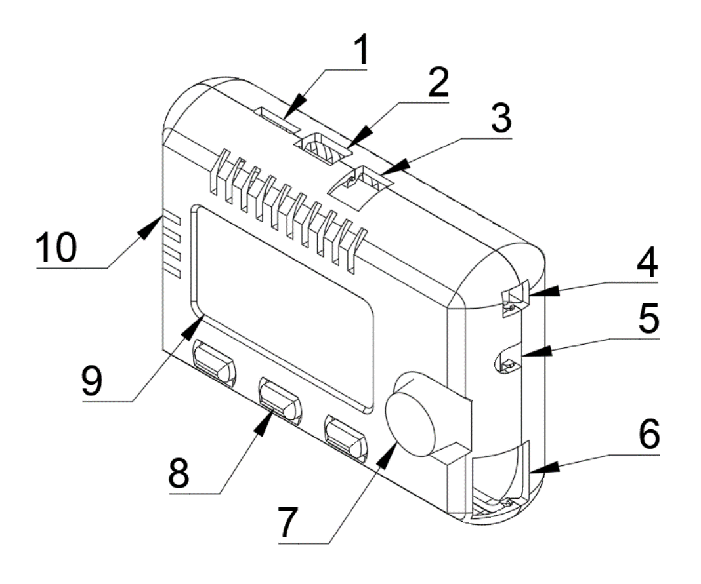
1 | Micro SD card slot
2 | Micro USB connection
3 | 12V 3A DC power connector
4 | Vibrator power connector
5 | Airline Pressure Connector*
6 | Accessory Port Connector**
7 | Scroll knob and select button
8 | Menu buttons
9 | Display Screen
10 | Air vents
* The location of the pressure sensor may vary slightly but performs the same function.
** This is not an Ethernet jack. Do not connect this to a LAN or other unsupported devices, you could damage your device.

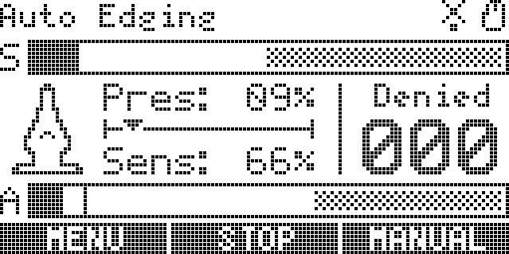
Main Screen
2
6
5
7
8
4
3
1
Figure 2 – Main Screen
1 | Current status / mode text
2 | Status icons
3 | Motor speed / max meter
4 | Arousal / peak limit meter
5 | Inflation indicator icon
6 | Pressure and Sensitivity readings
7 | Orgasm denial counter
8 | Menu button actions

The main screen contains some elements common to the device UI. Those include the current status or mode (1), status icons (2), and labels that correspond to the buttons under the display (8).
The two horizontal meters, “S” and “A” represent the Motor (vibration) speed, and Arousal value. As the device detects orgasm, the Arousal meter will fill. The shaded area represents the maximum value before vibration is stopped. The Motor meter’s shared area represents the maximum value for automatic ramp-up, which can be changed in the Edging Settings menu.
While the device is in Manual mode, you can turn the knob to adjust Motor speed. When the device is in Automatic mode, turning the knob adjusts the Arousal cutoff amount (threshold). As the Arousal meter decays, a peak line will stay for a moment. It is recommended that you use this peak line to tune the cutoff limit.
The main screen also includes an inflation level icon (5) which indicates any overpressure events. It is recommended that you keep this icon in a semi-inflated state. The pressure bars to the right (6) will show you the current pressure reading and sensitivity. Pressure sensitivity can be adjusted to boost the pressure reading and compensate for various plugs.
The left button (8) will toggle between Edging Menu and Stats view. The main view is the Stats view. The middle button will immediately stop vibration and enter Manual mode. The right button will toggle between Manual and Automatic mode.

Chart View
This shows a running graph of a dotted line (1) which represents the current pressure reading.
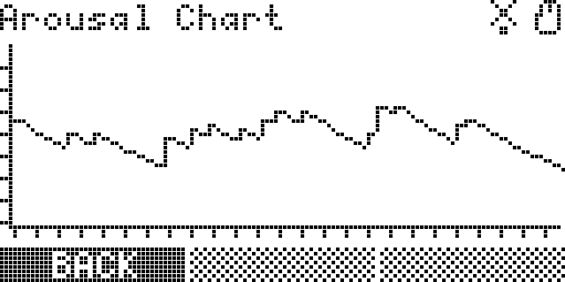
1
Figure 3 - Chart view, Automatic Mode
In this display, when the dotted pressure reading line reaches the top of the graph, vibration will be stopped.

Manual Operation
Manual mode disables the auto-ramping feature and auto-cutoff, giving you complete control of the vibrator speed. During Manual operation, you can turn the knob to adjust vibrator speed. Pressing the “Stop” button will set the vibrator speed to 0% and enter Manual mode.
Orgasm detection will NOT stop the vibrator in manual mode, so try not to ruin your session!
To return to Automatic mode, press the “Auto” button on the home screen. Vibration will resume automatic control.

Automatic Edging Mode
During Automatic Edging Mode, the vibrator will ramp up to a set maximum speed during a set time period. While in this mode, the device monitors pressure changes and attempts to detect orgasm. When an orgasm is detected, vibration is stopped for a moment to allow the user to cool off, then the ramp-up restarts.
It is important that the butt plug is properly inserted, and the sensitivity is calibrated to optimal peak detection. Please see “First Session Setup” for details on setup and calibration.
Once pressure sensitivity is adjusted properly, orgasm detection can be adjusted on the fly by using the Arousal cutoff (threshold) to allow for more arousal before stopping vibrations. This is done by turning the knob in Automatic mode. For convenience, the most recent peak in Arousal is persisted in the “A” Meter as a solid line. This should fall in the shaded region if that peak was pre-orgasm.

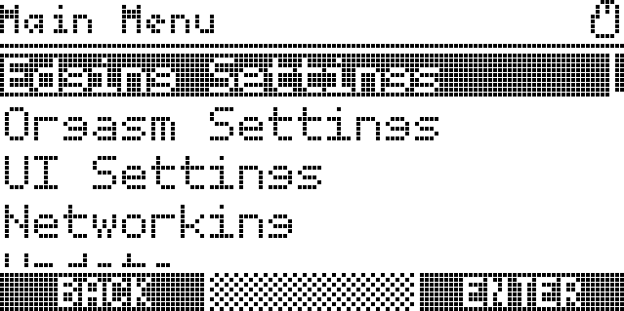
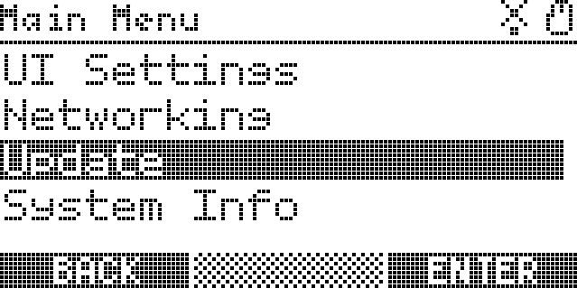
Main Menu

Figure 4 - Main Menu
The Main Menu can be accessed by pressing the scroll wheel down on any screen. While in menus, the scroll wheel is used to navigate between options. To select an option or save a value, press the scroll wheel. Sometimes, other options appear on the bottom of the screen, use the corresponding blue buttons to access these.
While you are in the main menu, the device will continue to operate. If you adjust any settings which temporarily take control of vibration speed, you may need to stop and restart Automatic mode to resume proper operation.
If you enter another mode/application the device will exit the normal run mode (Automatic/Manual operation) and that new mode will take control. At this time additional applications have not been developed.

Edging Settings
Edging Settings controls the automatic orgasm detection parameters and behavior of the auto-ramping vibration modes. Each of these settings is described below:
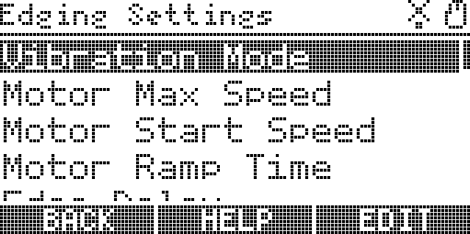
Figure 5 - Edging Settings menu
Vibration Mode – This selects the vibration / speed output based on the current arousal detection. There are 3 main modes of operation within this setting:
Depletion: This mode will ramp up vibrations to a limit, but reduce the intensity of the vibrations by slowing the vibrator speed as you approach the set limit, eventually converging on 0 speed, or stopped.
Enhancement: This mode will start at 0 speed or stopped, and increase the intensity of the vibrations by increasing the vibrator speed as you approach the set limit, eventually converging on max speed.
Ramp-Stop: This mode will ramp the speed up to Motor Max Speed until the Arousal Threshold is reached and then stop immediately for a short period. Max Additional Delay time will be randomized and added to this delay if set (see below).
Motor Max Speed – The maximum speed the vibrator motor will ramp up to in Automatic mode.
Motor Start Speed – The minimum speed the motor will start at in automatic mode.
Motor Ramp Time – The time (in seconds) that it takes for the vibrator motor to fully ramp up to in Automatic mode.
Edge Delay – Minimum time (ms) after edge detection before resuming stimulation.
Max Additional Delay – Maximum time (ms) that can be added to the edge delay before resuming stimulation. A random number will be picked between 0 and this setting each cycle. 0 to disable.
Minimum On Time – Time (ms) after stimulation starts before edge detection is resumed.
Arousal Limit – The Arousal threshold before orgasm is detected. This can be changed on the Automatic mode home screen.
Sensitivity Threshold – T The arousal threshold for orgasm detection. Lower values stop sooner.
Sensor Sensitivity – This value will amplify the signal coming in from your butt plug. If you find that your pressure is reading low, adjust this value to increase the pressure reading without increasing the butt plug pressure. Ideally, you want to adjust this so that the pressure reading is around 60%.
When you edit a numeric setting, you can use the scroll wheel to adjust the value. To save it, press “Save” or press the scroll wheel. Data is automatically written to the SD card and updated.
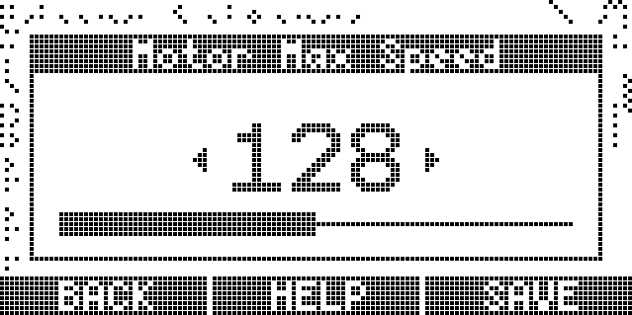
Figure 6 - Example of setting change
Most settings have a value of 0-255, which is converted to a percentage on the bar below the value. For complete documentation on all settings, including those which were not covered in the UI, please refer to the “Using the SD Card” section.

Orgasm Settings
Edge Duration Minutes – How long to edge before permitting an orgasm.
Clench Time To Orgasm – Will activate Orgasm mode after user has surpassed the Edge Duration time. Hold a clench for set amount of time to allow orgasm. (Example: Set for 3 seconds? Must hold the clench for 3 seconds to allow orgasm. Holding a clench becomes very difficult once edged for over an hour. Have fun.)
Use Post Orgasm Mode – Allows you to extend the duration of Orgasm mode.
Post Orgasm Seconds – How long to stimulate after orgasm is detected.
Menu Lock - Edge – Deny access to menu starting in the edging session.
Menu Lock - Post – Deny access to menu starting after orgasm detected.
Use Clench Detector In Edging – Use the clench detector to adjust Arousal. (This is a community created setting. For additional support with this, please join our discord server. An invite link can be found on our website.)
Clench Pressure Sensitivity – Threshold over arousal to detect a clench: Lower values increase sensitivity. Minimum additional Arousal level to detect a clench. (Example: Arousal level set to 115? Need to clench at least 130 on the arousal meter before it registers as a clench.)

UI Settings
The Edge-o-Matic 3000 has a variety of UI settings that you can change to fit your personal preferences. Such options include:
- Language: Translation files can be downloaded.
- Screen Dim Delay: Time, in seconds, before the screen dims. 0 to disable.
- Screen Timeout: Time, in seconds, before the screen turns off. 0 to disable.
- LED Brightness: Status LED maximum brightness.
- Screensaver: Enable the screensaver to bounce around once the screen has timed out.
- Reverse Menu Scroll: Reverse the direction of the scroll wheel when navigating menus.

Network Settings
This menu allows you to enable/disable wireless communication technologies. You can view your connection status, which shows you your IP address when connected. (This is useful for browser-based connections). Connect to an authorized Maus-Bus™ accessory, and see a list of your connected accessories.
The Edge-o-Matic 3000 only supports a 2.4GHz network connection, it will not connect to a 5GHz network.

Using the SD Card
Your Micro SD file should contain a config.json file which contains all your device settings. This file is automatically generated by the device when you change settings and is loaded when the device boots. The current options are:
Network Settings
Key | Note
wifi_ssid | Your Wi-Fi SSID
wifi_key | Your Wi-Fi Password.
wifi_on | Enable Wi-Fi and the WebSocket server. Cannot be enabled if Bluetooth® is on.
websocket_port | Port to listen for incoming WebSocket connections.
use_ssl | Enable SSL server, which will eat all your RAM!
hostname | Local hostname for your device.
bt_display_name | Bluetooth device name, you might want to change this.
bt_on | True to enable the Bluetooth connection. Cannot be enabled if Wi-Fi is on.
force_bt_coex | Force Bluetooth and Wi-Fi at the same time**.
classic_serial | Output continuous stream of arousal data over serial for backwards compatibility with other software.
** Bluetooth and Wi-Fi coexistence is EXPERIMENTAL and may cause system instability. If your device resets with both turned on, please turn them back off. Additionally, it might be helpful to post some info in discord of the last serial dump on the console when your device resets, assuming you have a console connected.
Vibrator settings
Key | Note
vibration_mode | Vibration Mode for main vibrator control.
Ramp-Stop | ID: 1
Depletion | ID: 2
Enhancement | ID: 3
Global Sync | ID: 0 When set on secondary vibrators, they will follow the primary vibrator speed.

UI Settings
Key | Note
led_brightness | Status LED maximum brightness.
screen_dim_seconds | Time, in seconds, before the screen dims. 0 to disable.
screen_timeout_seconds | Time, in seconds, before the screen turns off. 0 to disable.
reverse_menu_scroll | Reverse the direction of the scroll wheel when navigating menus.

Orgasm Settings
Key | Note
motor_start_speed | The minimum speed the motor will start at in automatic mode.
motor_max_speed | Maximum speed for the motor in auto-ramp mode.
pressure_smoothing | Number of samples to take an average of. Higher results in lag and lower resolution!
sensitivity_threshold | The arousal threshold for orgasm detection. Lower = sooner cutoff.
motor_ramp_time_s | The time it takes for the motor to reach motor_max_speed in auto ramp mode.
update_frequency_hz | Update frequency for pressure readings and arousal steps. Higher = crash your serial monitor.
sensor_sensitivity | Analog pressure prescaling. Adjust this until the pressure is ~60-70%
use_average_values | Use average values when calculating arousal. This smooths noisy data.
edge_delay | Minimum time (ms) after edge detection before resuming stimulation.
max_additional_delay | Maximum time (ms) that can be added to the edge delay before resuming stimulation. A random number will be picked between 0 and this setting each cycle. 0 to disable.
minimum_on_time | Time (ms) after stimulation starts before edge detection is resumed.

Post-Orgasm Settings
Key | Note
use_post_orgasm | Use post-orgasm mode and functionality.
clench_pressure_sensitivity | Minimum additional Arousal level to detect clench.
clench_time_to_orgasm_ms | Threshold variable that is milliseconds count of clench to detect orgasm.
clench_detector_in_edging | Use the clench detector to adjust Arousal.
auto_edging_duration_minutes | How long to edge before permitting an orgasm.
post_orgasm_duration_seconds | How long to stimulate after orgasm detected.
edge_menu_lock | Deny access to menu starting in the edging session.
post_orgasm_menu_lock | Deny access to menu starting after orgasm detected.
max_clench_duration_ms | Duration the clench detector can raise arousal if clench detector turned on in edging session.
clench_time_threshold_ms | Threshold variable that is milliseconds counts to detect the start of clench.

Post-Orgasm Duration Seconds
Seconds | Note
0 | Turn off stimulation at orgasm detection - Failed Orgasm
5-15 | Turn off stimulation after number of seconds - Normal orgasm
16-4095 | Turn off stimulation after number of seconds - Post orgasm Torture

SD Card Continued

Future software updates may introduce new variables. If this is the case, your device should automatically update the file with any new values after your first config change.
If you wish to revert your configuration options to the default values, simply remove that line from the file and restart the device. Any missing values will be added automatically.
This file uses JSON syntax, and it is critical that the options object is properly structured. If you are unsure of what you are doing, use an online JSON linter to help you.

Data Recording
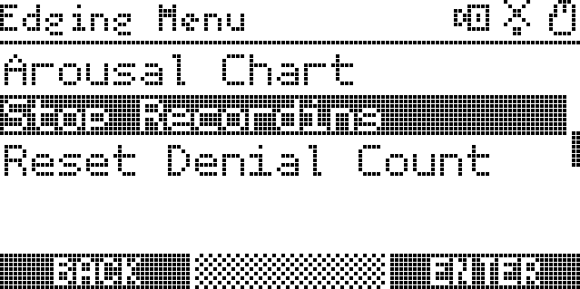
Data recording can be started by pressing the menu button on the bottom left side of the main screen. The option to ‘Start Recording’ will be found there. These files are stored on the root of your SD card.
1
Figure 7 - Screen while recording
While recording, you will notice the camera icon (1) on the top right appears. Data from this recording is being saved to your SD card as a CSV file containing rows of readings emitted every tick (update frequency, by default, 60 readings / second). The CSV headers will identify the data columns.
This is useful for analyzing pressure readings during orgasm and further improving your orgasm detection. Additionally, this file can be supplied to developers to help improve the detection algorithms. It does not contain any personally identifiable information, only sensor readings.

Installing Firmware Updates
If you are connected to Wi-Fi, you will be able to install the latest firmware updates when you select “Update” from the Main Menu. These will be downloaded from the Maus-Tec server and installed automatically, without a need for copying files or using an SD card!
Updates can be manually installed from the Micro SD card as a .bin file, called “update.bin”. On a computer, copy this file over to the root of your SD card, insert the card into your device, and power on the device. In the main menu, select “Update” again:
Figure 8 - Menu update option

Select this by pressing the thumbwheel or using the enter button on the lower right side of the screen, and the update process will begin. If a valid firmware image was found on your SD card, after which your device reboots automatically into the new software version. If the firmware image was invalid, or an error occurred while installing updates, you should see an appropriate error displayed on screen.

Conclusion
Need additional help? Email us at: info@maustec.io
Check out our help desk: support.maustec.io
This project is in active development, and the contents herein are subject to change at any time and for any reason. For up-to-date information regarding the Edge-o-Matic 3000 and its associated devices, visit our website at maustec.io and search for Edge-o-Matic.
THIS IS A SEX TOY INTENDED FOR ADULTS OVER THE AGE OF 18. The user is responsible for practicing proper hygiene when it comes to the cleaning and use of the equipment and its accessories. Use of this toy is done at your own risk, and it is strongly recommended you educate yourself on the safe use of insertable sex toys.
The ability to detect orgasm via pelvic floor contraction is experimental. While this device has been shown to work in many participants, it cannot be entirely accurate without further research. As improvements are made in the detection algorithm, updates will be provided for your device. The level of accuracy in orgasm detection is not guaranteed for all users. Every effort is being made to develop a universal algorithm.
Maus-Tec® and Edge-o-Matic® are registered trademarks of Maus-Tec LLC. Maus-Bus™ is a trademark of Maus-Tec LLC.
The Bluetooth® word mark and logos are registered trademarks owned by Bluetooth SIG, Inc. and any use of such marks by Maus-Tec LLC is under license. Other trademarks and trade names are those of their respective owners.

